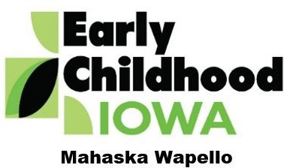
Quality Improvement for Early Childhood / FY26 Mini Grant Request $4999 Cap

This project request for use of MWECI funds falls under the following ECI / Tool O Description:
This program is designed to enhance the standards and effectiveness of programs that serve young children and their families. This service supports a wide range of community-based programs, family support initiatives, and early learning providers. The initiative emphasizes the strengthening of program quality through evidence-based strategies, accreditation support, and group-based learning opportunities. Programs are encouraged to achieve and maintain high standards, contributing to better outcomes for children and families.

These mini grants may be used to help programs purchase materials or receive professional services focused on feasibility studies tailored to strategies focused on improving learning environments and service delivery. By investing in quality improvement, this service helps programs elevate their standards, expand their impact, and help children receive high-quality care and education in their earliest years.

Applicant Organization / Address:
Contact Name / Email:
Date of Application:
Total Amount of Funds Requested:
What: (Describe the project)
When: (Provide a date or timeline)
Who: (Describe who # will benefit)
How: (Describe benefits of the project)

Why: (Describe why you chose this project and relationship to quality improvement)

Anticipated / Projected Project Inputs, Outputs, Quality/Efficiency, and Outcomes:

INPUTS:

# of children impacted by the funding

# ages of children impacted by the funding

# of environments impacted

OUTPUTS:

# of programs served

# of types of programs

# of programs provided one time funding for materials

QUALITY/EFFICIENCY:

# of programs meeting a quality initiative

OUTCOMES:

# of programs that report an increase in improving knowledge and or improve their quality

Identify additional funding sources and amount (if any):

Project Budget: (Line Items & Justification Statement) | Requested Funds:
Total Requested:

To be completed by the MWECI Director:
Date MWECI received application:
Date MWECI approved funds for this project:
Date MWECI sent MOU:
Date MWECI received signed MOU:
Date this project was completed:

